National University of Computer and Emerging Sciences



**Laboratory Manual**

***(Introduction to Computing)***

|  |  |
| --- | --- |
| Course Instructor | Dr. Zareen Alamgir |
| Lab Instructor(s) | Ismaeel Haider, Ahmad Raza |
| Section | G |
| Semester | FALL-2016 |

Department of Computer Science

FAST-NU, Lahore

***How to use Visual Studio: (Revision)***

***Step 1:***

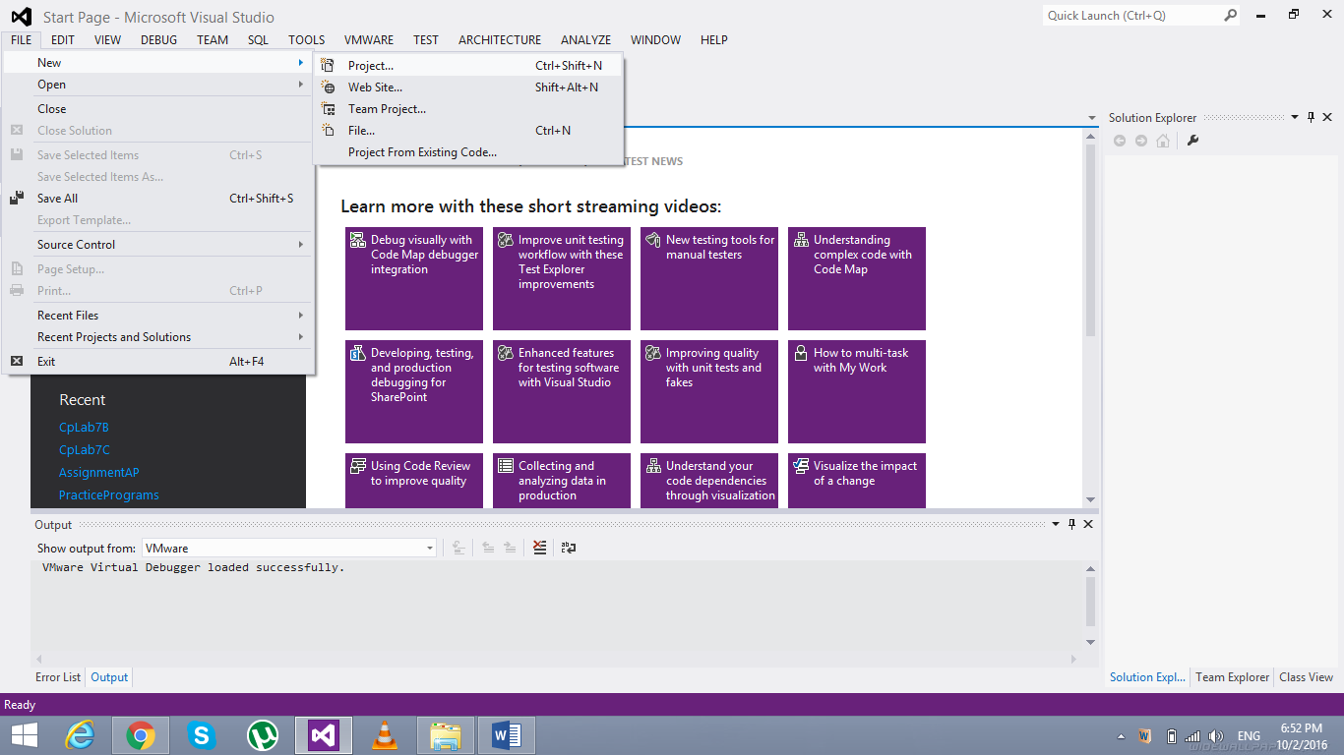

***Step 2:***

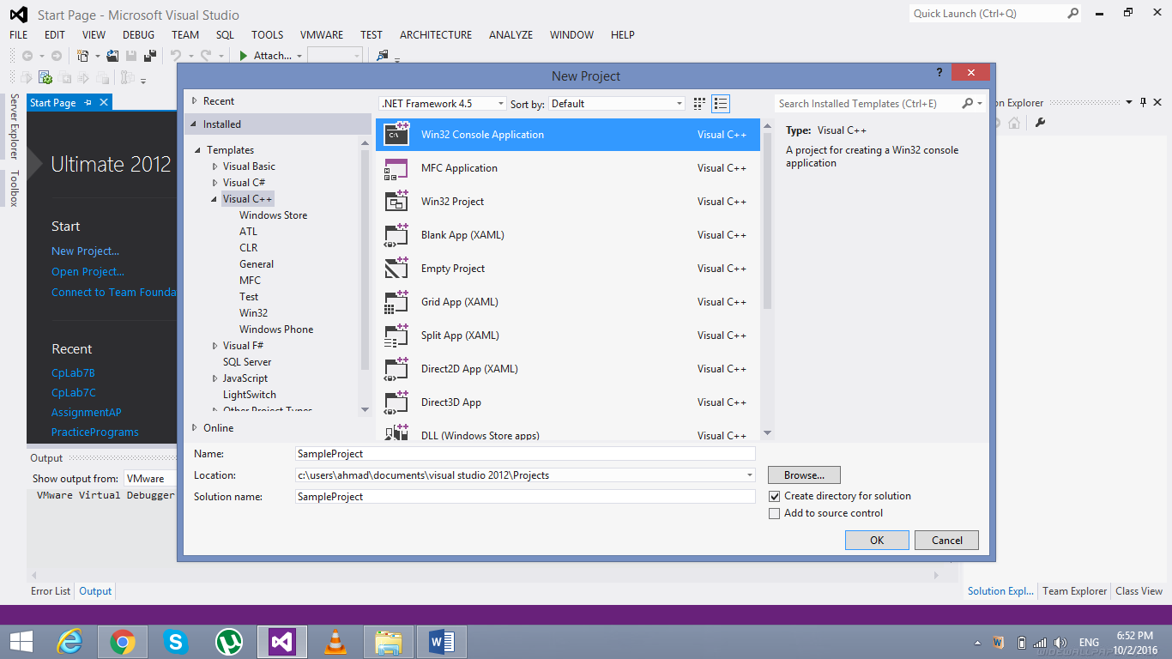

***Step 3:***

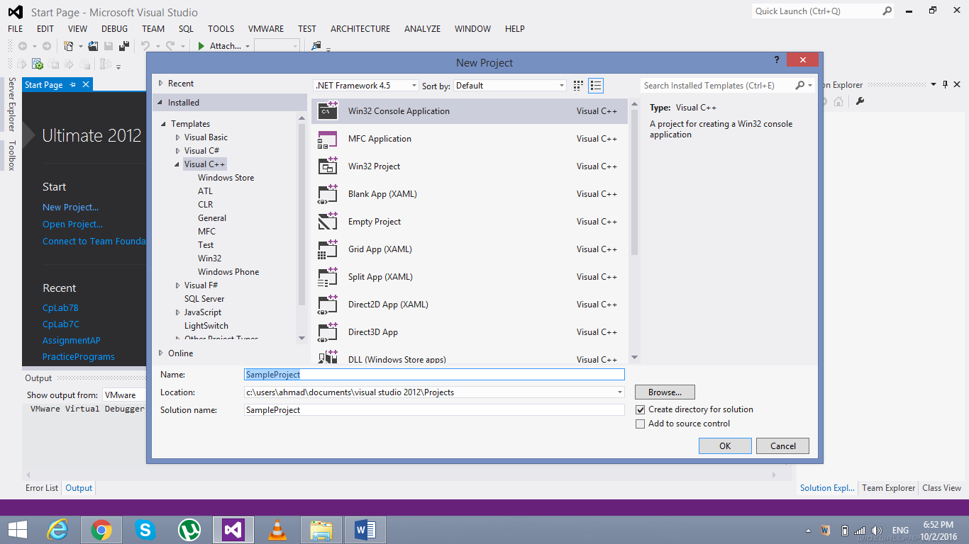

***Step 4:***

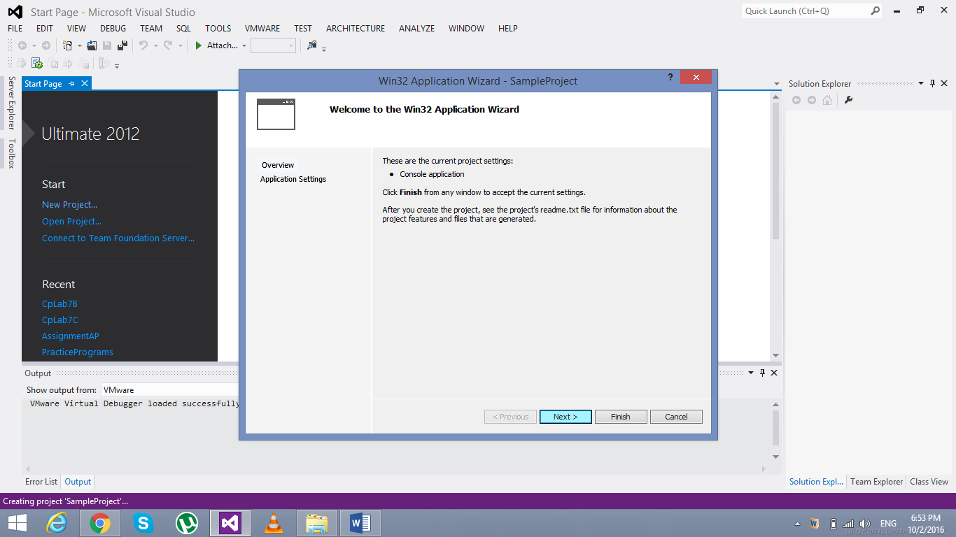

***Step 5:***

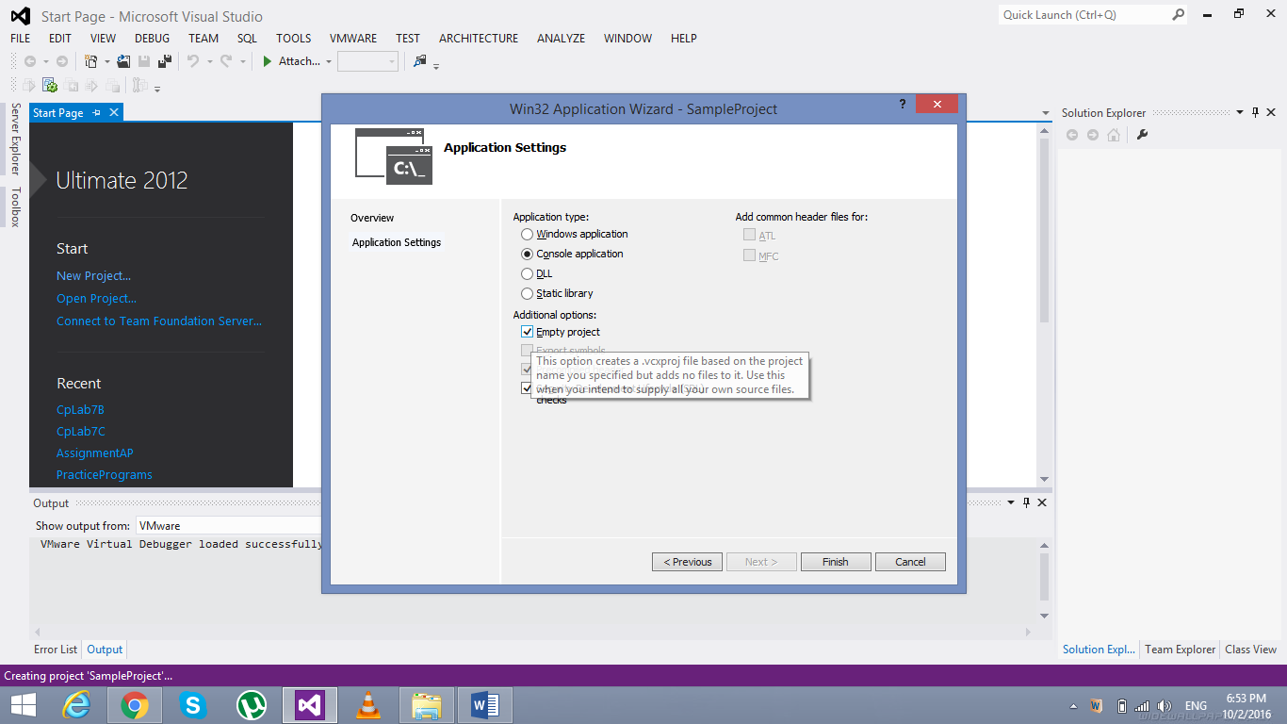

***Step 6:***

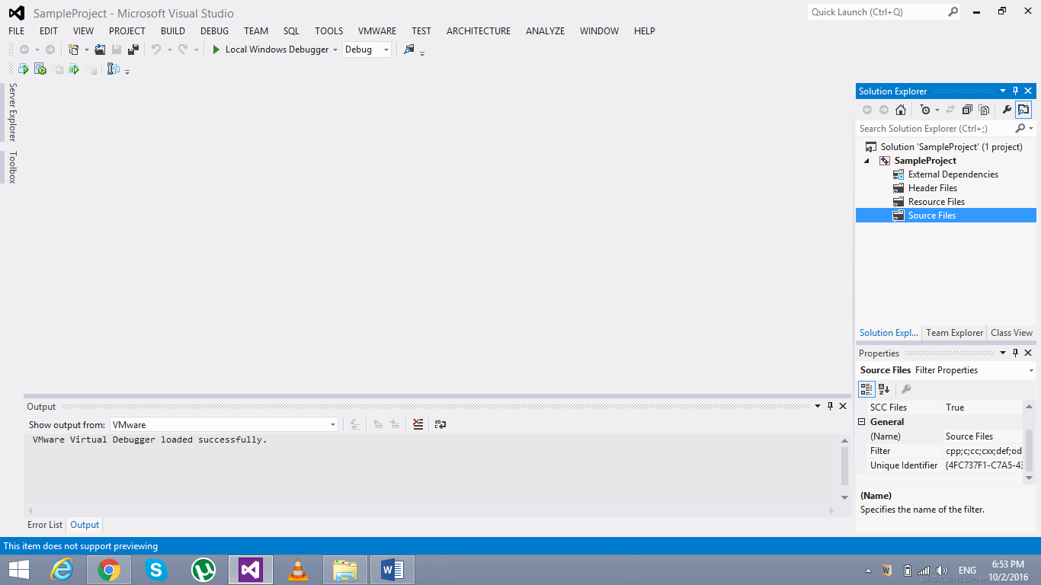

***Step 7:***

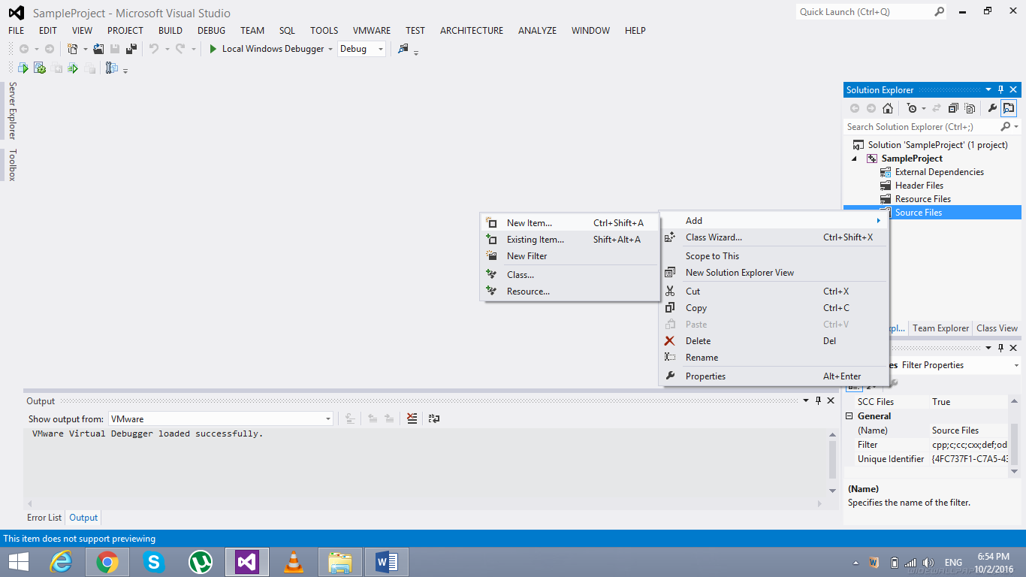

***Step 8:***

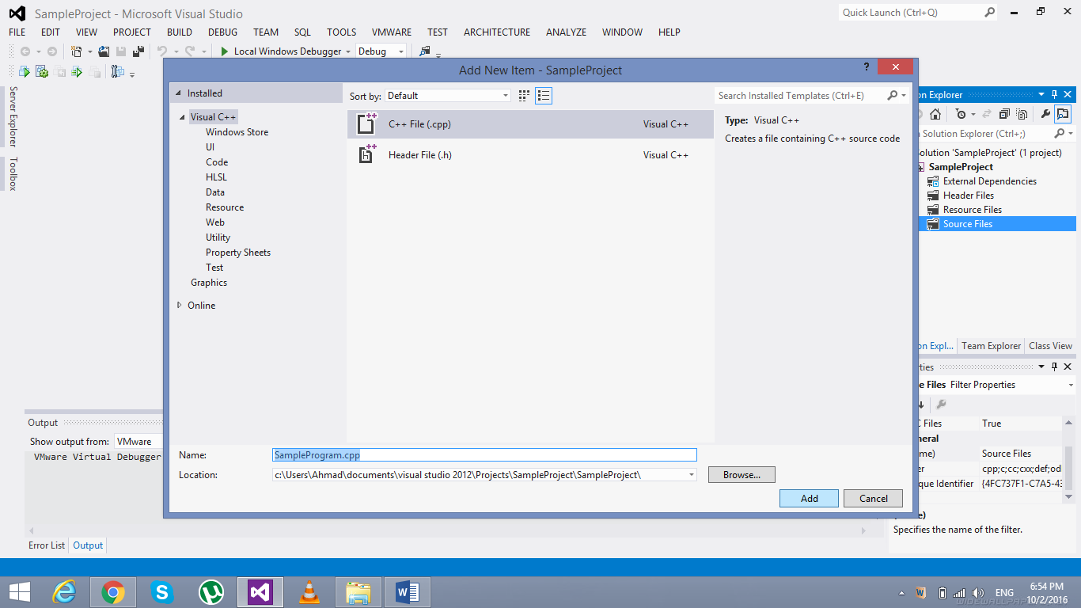

***Step 9:***

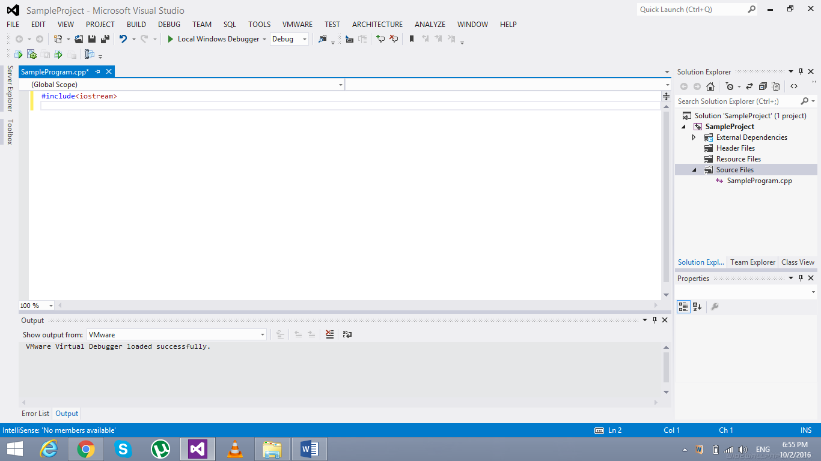

***How to show Error List: (If it’s not shown)***

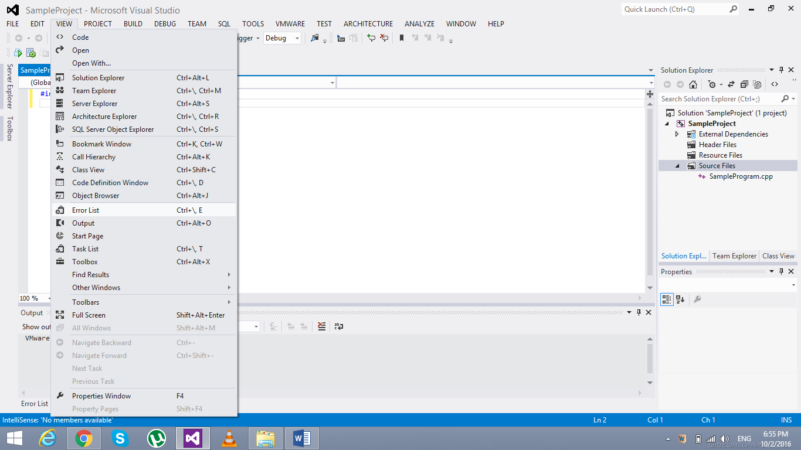

***Error List:***

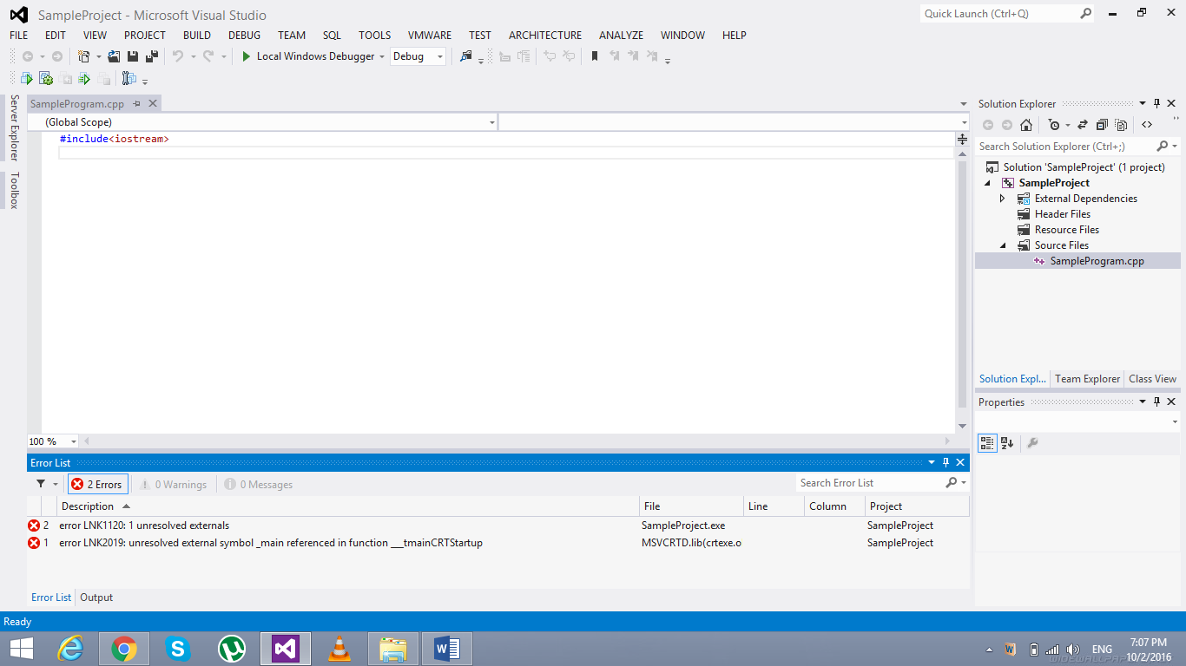

***Remember:*** *Honesty always gives fruit (no matter how frightening is the consequence); and*

*Dishonesty is always harmful (no matter how helping it may seem in a certain situation)!*